BJT Performance Card Name: ________________

Device ID: ________________

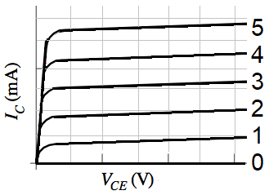

|  |  |
| --- | --- |
| Trace | ib (uA) |
| 9 |  |
| 8 |  |
| 7 |  |
| 6 |  |
| 5 |  |
| 4 |  |
| 3 |  |
| 2 |  |
| 1 |  |
| 0 |  |

|  |  |  |  |  |  |
| --- | --- | --- | --- | --- | --- |
| Ch1 Scale | Volts/div |  | vce | Ch1 Scale * 1 volts/volt | Volts/div |
| Ch2 Scale | Volts/div |  | ic | Ch2 Scale * 4.55mA/volt | mA/div |

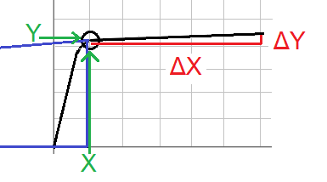Gain Calculation

|  |  |  |  |
| --- | --- | --- | --- |
| Trace | #Divs | ic(mA) | ic/ib |
| 9 |  |  |  |
| 8 |  |  |  |
| 7 |  |  |  |
| 6 |  |  |  |
| 5 |  |  |  |
| 4 |  |  |  |
| 3 |  |  |  |
| 2 |  |  |  |
| 1 |  |  |  |
| 0 | 0 | 0mA | ------ |

Early Voltage

|  |  |  |  |  |  |  |
| --- | --- | --- | --- | --- | --- | --- |
| Trace | X | Y | ΔY | ΔX | X- Y (ΔX/ ΔY) | * Ch1 Scale |
| 9 |  |  |  |  |  |  |
| 8 |  |  |  |  |  |  |
| 7 |  |  |  |  |  |  |
| 6 |  |  |  |  |  |  |

BJT Performance Card Name: ________________

Device ID: ________________



|  |  |
| --- | --- |
| Trace | ib (uA) |
| 9 |  |
| 8 |  |
| 7 |  |
| 6 |  |
| 5 |  |
| 4 |  |
| 3 |  |
| 2 |  |
| 1 |  |
| 0 |  |

|  |  |  |  |  |  |
| --- | --- | --- | --- | --- | --- |
| Ch1 Scale | Volts/div |  | vce | Ch1 Scale * 1 volts/volt | Volts/div |
| Ch2 Scale | Volts/div |  | ic | Ch2 Scale * 4.55mA/volt | mA/div |

Gain Calculation

|  |  |  |  |
| --- | --- | --- | --- |
| Trace | #Divs | ic(mA) | ic/ib |
| 9 |  |  |  |
| 8 |  |  |  |
| 7 |  |  |  |
| 6 |  |  |  |
| 5 |  |  |  |
| 4 |  |  |  |
| 3 |  |  |  |
| 2 |  |  |  |
| 1 |  |  |  |
| 0 | 0 | 0mA | ------- |

Early Voltage

|  |  |  |  |  |  |  |
| --- | --- | --- | --- | --- | --- | --- |
| Trace | X | Y | ΔY | ΔX | X- Y (ΔX/ ΔY) | * Ch1 Scale |
| 9 |  |  |  |  |  |  |
| 8 |  |  |  |  |  |  |
| 7 |  |  |  |  |  |  |
| 6 |  |  |  |  |  |  |